1. **Look over the online documentation for front panel. What is maximum data transfer rates when using Block Throttled Pipe Out? (5 pts)**



1. **Describe the output signals from the image sensor necessary to acquire an image in parallel read out mode? (5 pts)**

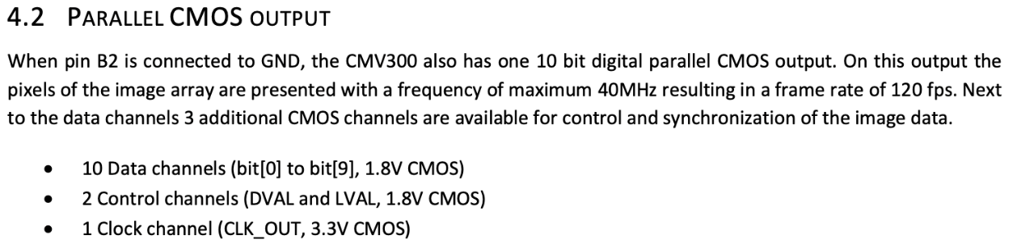

1. **Draw a block diagram of the FSM that will enable you to read a single frame of data from the image sensor. Summarize how would you implement the FSM in Verilog. (20 pts)**

